**Paediatric Massive Transfusion Protocol (MTP)**

Massive transfusion in children is defined as transfusion of >40 ml/kg (blood volume in children >1 month old is approximately 80 ml/kg)

MTP hotline blood bank: dial extension **_______** (check with your own institution)

See below for eg of a MTP activation chart. 

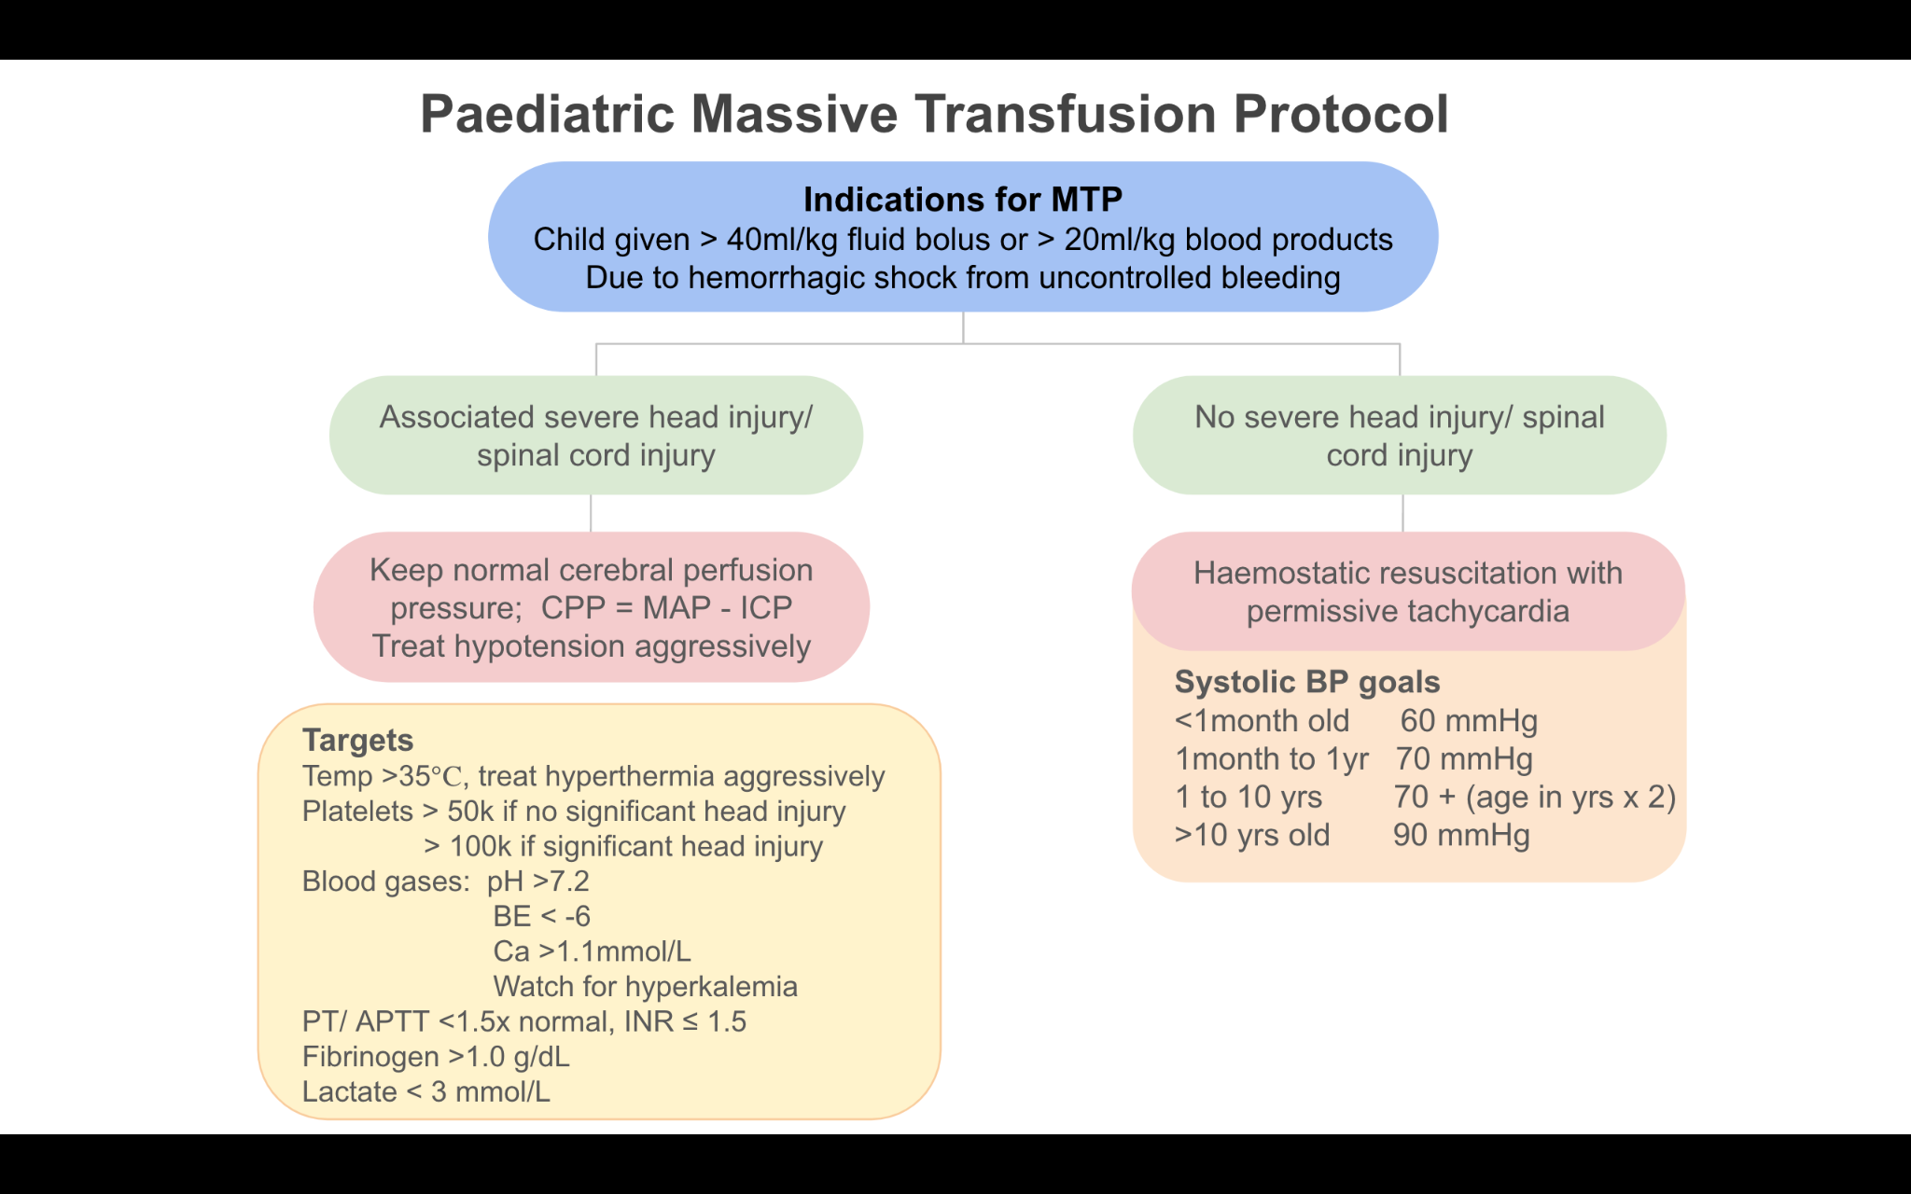



Monitor for:

1. Temperature >35 and treat hyperthermia aggressively
2. Treat hypotension aggressively in children with head injury or spinal cord injury
3. Platelets

* Keep platelets ≥ 50 x 109/L if NO significant head injury present
* Keep platelets ≥ 100 x 109/L in presence of significant head injury

1. Blood gases/ electrolytes

* pH >7.2
* Base excess < –6
* Ca 2+ > 1.1mmol/L
* Monitor for hyperkalemia

1. Coagulation profile

* PT/ aPTT < 1.5x normal
* INR ≥1.5

1. Fibrinogen >1g/L
2. Lactate < 3 mmol/L